CHANGES HISTORY
PIC | Date | Remarks
BJM.MR | 2018.05.02 | Created
Ghaida | 2018.05.02

TOC
- Master Portfolio
- Master Fund

Diagram ENTITY RELATIONSHIP
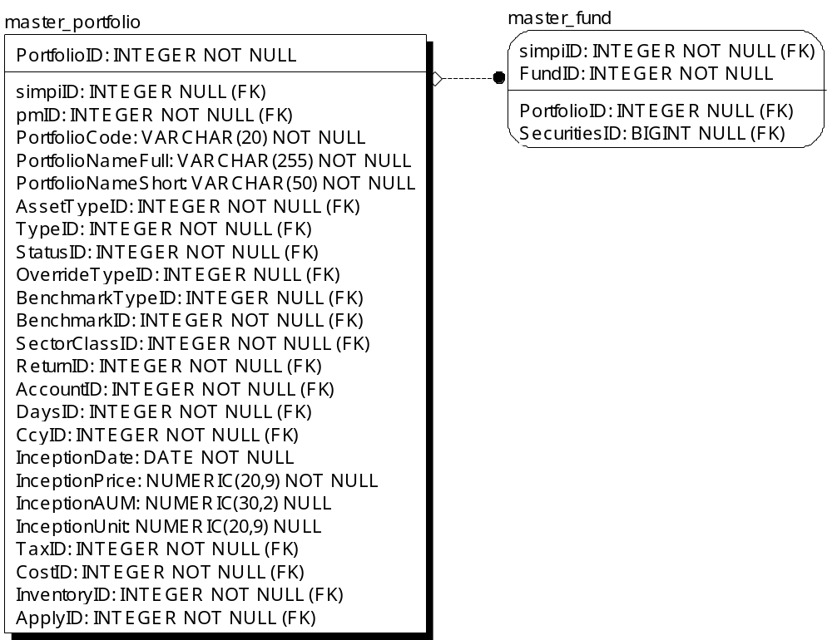

TABLE RELATIONSHIP
No | Table 1 | Table 2 | Type (1:1; 1:N; M:N) | Description
 | master_portfolio | master_fund | 1:1

Name |  | master_portfolio
Objective
No | Column |  | Type | Rule  (PK, FK, Key, NN, Unik, Index) | Description
1. | PortfolioID |  | Integer | NN
2. | simpiID |  | Integer | FK, Null
3. | pmID |  | Integer | FK
4. | PortfolioCode |  | Varchar(20) | NN
5. | PortfolioNameFull |  | Varchar(255) | NN
6. | PortfolioNameShort |  | Varchar(50) | NN
7. | AssetTypeID |  | Integer | FK
8. | TypeID |  | Integer | FK
9. | StatusID |  | Integer | FK
10. | OverrideTypeID |  | Integer | FK, Null
11. | BenchmarkTypeID |  | Integer | FK,Null
12. | BenchmarkID |  | Integer | FK
13. | SectorClassID |  | Integer | FK
14. | ReturnID |  | Integer | FK
15. | AccountID |  | Integer | FK
16. | DaysID |  | Integer | FK
17. | CcyID |  | Integer | FK
18. | InceptionDate |  | Date | NN
19. | InceptionPrice |  | Numeric(20,9) | NN
20. | InceptionAUM |  | Numeric(30,2) | Null
21. | InceptionUnit |  | Numeric(20,9) | Null
22. | TaxID |  | Integer | FK
23. | CostID |  | Integer | FK
24. | InventoryID |  | Integer | FK
25. | ApplyID |  | Integer | FK

SAMPLE DATA
No | Column | Sample 1 | Sample 2 | Sample 3 | Sample 4
1. | PortfolioID | 50 | 51 | 85 | 82
2. | simpiID | 70 | 70 | 71 | 70
3. | pmID | 812 | 3/22/1902 | 3/22/1902 | 3/22/1902
4. | PortfolioCode | ABCS | AECS | LTEAS | AASBSY
5. | PortfolioNameFull | Avrist Balance Cross Sectoral | Avrist Equity Cross Sectoral | Fund on Fund Life Trading - Equity Amar Syariah | Reksa Dana Avrist Ada Sukuk Berkah Syariah
6. | PortfolioNameShort | Avrist Balanced Cross Sectoral | Avrist Equity Cross Sectoral | Life Trading - Equity Amar Syariah | Avrist Ada Sukuk Berkah Syariah
7. | AssetTypeID | 3 | 1 | 1 | 2
8. | TypeID | 1 | 1.00 | 9.00 | 1.00
9. | StatusID | 2 | 2 | 2 | 2
10. | OverrideTypeID | 2 | 2 | 3 | 3
11. | BenchmarkTypeID | 1 | 1 | 1 | 1
12. | BenchmarkID | 4 | 2 | 6 | 6
13. | SectorClassID | 1 | 1 | 1 | 1
14. | ReturnID | 1 | 1 | 2 | 2
15. | AccountID | 2 | 2 | 1 | 2
16. | DaysID | 1 | 1 | 3 | 3
17. | CcyID | 1 | 1 | 1 | 1
18. | InceptionDate | 5/15/2013 | 5/15/2013 | 7/31/2017 | 8/7/2017
19. | InceptionPrice | 1000 | 1000 | 1000 | 1000
20. | InceptionAUM
21. | InceptionUnit
22. | TaxID | 1 | 1 | 1 | 1
23. | CostID | 2 | 2 | 1 | 1
24. | InventoryID | 1 | 1 | 2 | 2
25. | ApplyID | 2 | 2 | 2 | 2

Name |  | master_fund
Objective
No | Column |  | Type | Rule  (PK, FK, Key, NN, Unik, Index) | Description
1. | simpiID |  | Integer | FK
2. | FundID |  | Integer | NN
3. | PortfolioID |  | Integer | FK, Null
4. | SecuritiesID |  | BIGInteger | FK, Null

SAMPLE DATA
No | Column | Sample 1 | Sample 2 | Sample 3 | Sample 4
1. | simpiID
2. | FundID
3. | PortfolioID
4. | SecuritiesID

